Motion Sensor Lights

Project POGGERS: Peripheral Observatory Graphical Generator Emitting Radiance System

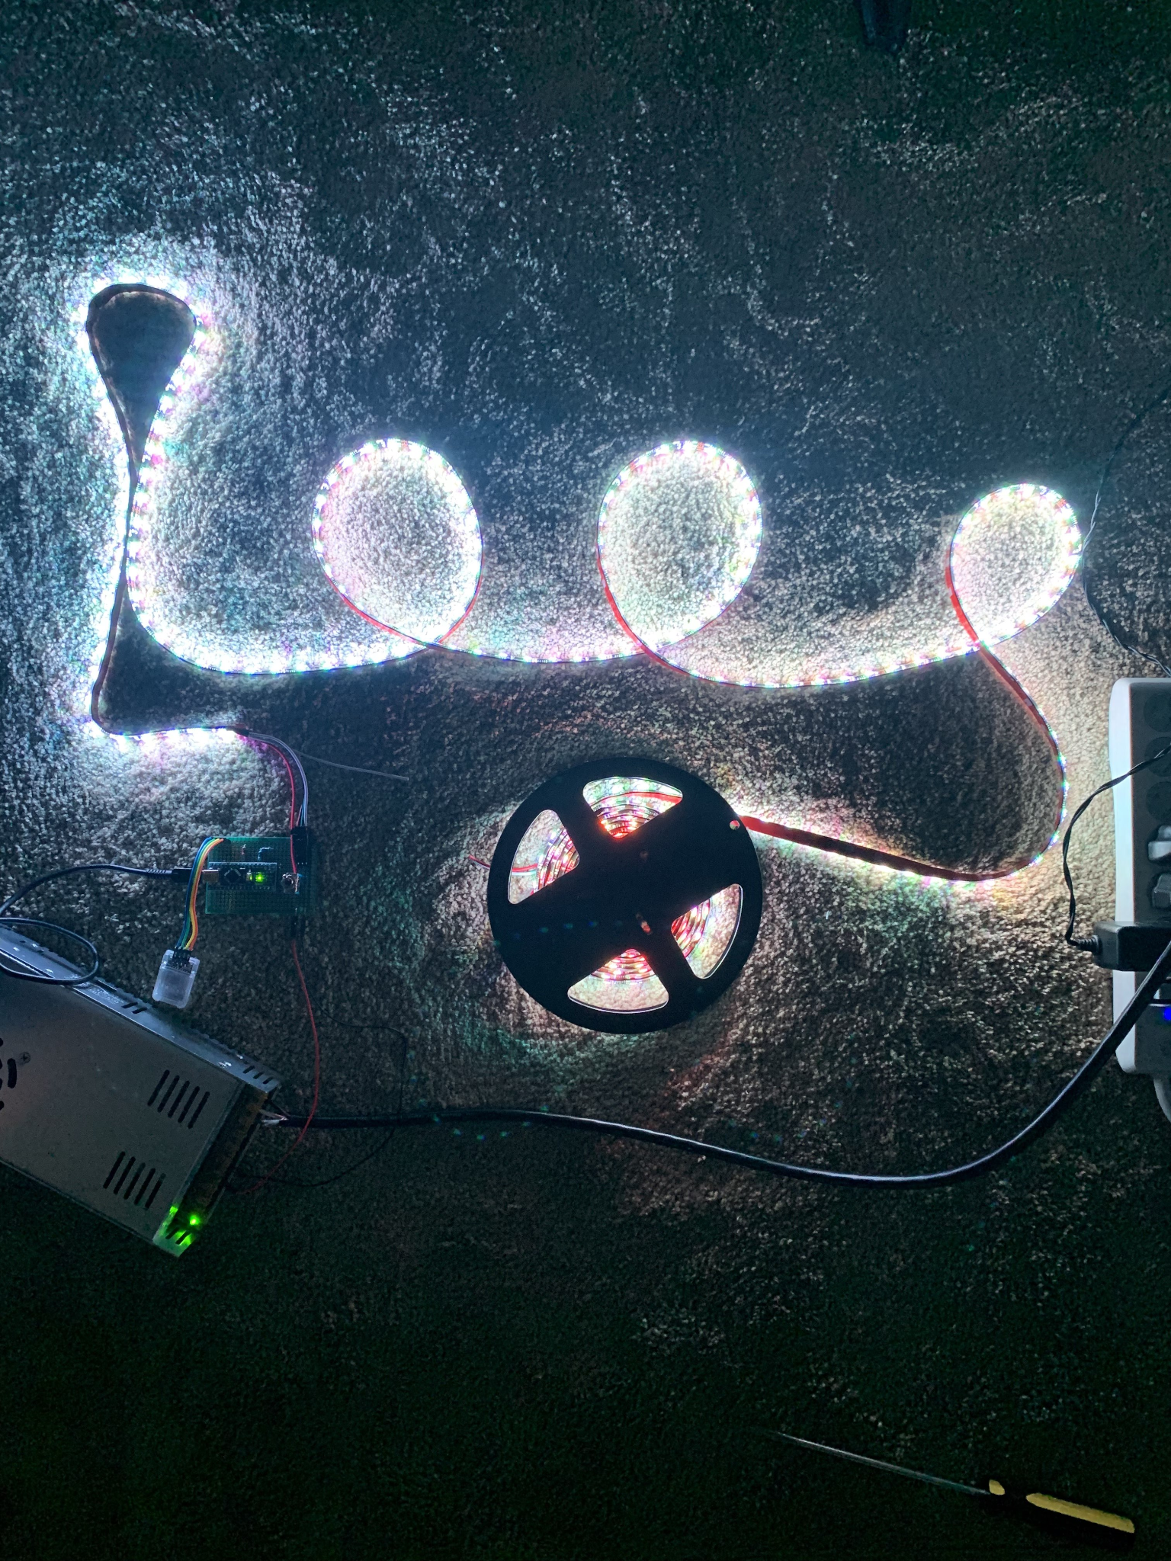

# **Introduction**

Our project uses a camera connected to a Raspberry Pi that feeds its video input through a neural network. The neural network determines if a person is within the frame. If a person is detected, the Raspberry Pi communicates with the Arduino Nano via BLE bluetooth. Furthermore, a microphone is connected to the Raspberry Pi, which is set to detect high pitched audio.

# **Motivation**

Has this ever happened to you? You walk into your room and your hand just can’t find the light switch. You reach and reach and reach until you fall over, knock over your vase, and stub your toes. Well no more, introducing the all new Motion Sensor Lights. With these automated lights, anyone can turn the light on from anywhere in the room by clapping, walking, or sending a message on their phone.

# **Materials**

1. Raspberry Pi 3 B+
2. IR Raspberry Pi Camera
3. Arduino Nano
4. DSD Tech HM-10 Bluetooth 4.0 BLE module
5. Alitove WS2811 LED programmable strip lights
6. 12V 30A power supply
7. eBerry USB Microphone

# **Timeline**

Weeks 1-2: Decided the focus of our project: light animation. Set up power supply, LED strip, Arduino, and begin experimentation with LED patterns.

Weeks 3-4: Experiment with Raspberry Pi and camera for human detection, debated which neural network to use. Set up transmission of a serial message to the Arduino whenever a person is detected.

Weeks 5-6: Set up a clap-detection system on the Raspberry Pi to also send a serial message when two successive claps are detected. Continue working on LED patterns and decoding of serial messages to control output logic.

Weeks 7-8: Determine which bluetooth module to use and set up communication between the Raspberry Pi and Arduino Nano. Solder the bluetooth module onto the circuit board.

# **Approach**

**Initial Project and Materials**

Initially, our project consisted only of a PIR motion sensor and the LED strip lights. However, after completing the project in a single sitting, our group decided to add more functionality. We decided to use machine learning to detect the presence of humans, which was a step more complicated than basic motion detection.

In motion detection (in a computer vision aspect), a set of pixels is compared to the current image from the camera feed, in which the computer determines if a new object entered the perimeter. However, in machine learning, a neural network can be trained to specifically detect humans. This way, a moving object within the camera frame would not be regarded as a person.

At first, we wanted to use a thermal camera, since thermal visual information allows neural networks to be considerably more accurate than regular cameras. This is because humans emit thermal heat whereas our abiotic surroundings do not, which allows people to be visually distinguished from the background. In addition, the video feed of thermal cameras during the night would be virtually identical to the visual data during the day. As such, the neural network would be able to accommodate for a long range of background factors and distractions. However, the cost of purchasing a thermal camera and its necessary accessories exceeds eighty dollars, which is over twice the budget. Thus, we decided to buy an Infrared camera that was priced at a reasonable cost of $16.

**Object Detection**

Since none of us are experts in Artificial Intelligence or machine learning, we heavily relied on outside sources for our object detection neural network. Most neural networks online required further custom training, especially with cuda to enable GPU processing. Eventually, we found two potential neural networks to use: TinyYolo and TFLite. Although TinyYolo is a much faster version of the Yolo object detection algorithm, the Raspberry Pi is still too slow to effectively run the model. As such, we decided to use the TFLite model developed by Google, which allows mobile devices to run object detection algorithms. Even still, the network can only process to a maximum of two frames per second, which is not ideal to say the least.

The TFLite model is already pre-trained and does not require further training, although doing so would be optimal. It was trained with the COCO Dataset, which is a dataset of around 80 common objects that includes humans. As such, our model actually recognizes objects in the background, such as backpacks or stop signs, but we created an interface where communication to the arduino would be sent only if a person was detected.

**Clap Detection**

To detect claps using Python, we relied on the pyaudio third-party library to analyze the sound received from the microphone. We sample the audio at the default rate of 44100 HZ, and analyze the data with chunks of 1024 samples (this is all defined in the ClapTester() constructor method).

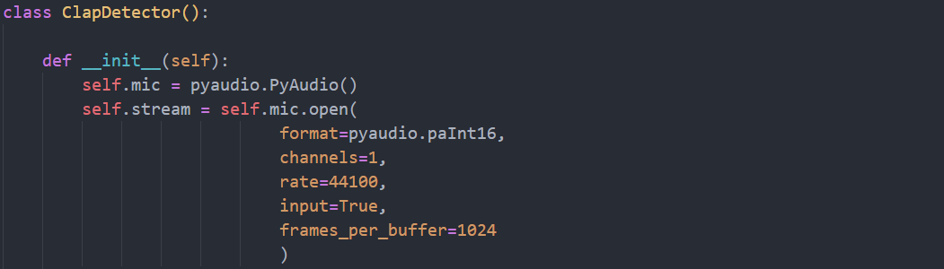

Since we are sampling the data at 44100 HZ and have chunk sizes of 1024 samples, each chunk takes 1024/44100 = 0.023 seconds (or 23 milliseconds) to process. We define a low chunk size so that the audio can be processed in smaller intervals, since claps usually last between 40-60 milliseconds. Whenever someone claps, the amplitude of the audio data increases exponentially. As such, we find the RMS amplitude of the chunk to determine if a clap occurred during the chunk. The RMS amplitude returns the square root of the average squares of values for a given signal. By doing so, we can get the average amplitude of the signal without worrying about the signs of the waves (since every data point is squared). The RMS for a given signal

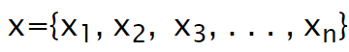

We calculate the RMS of the signal *x* to be:

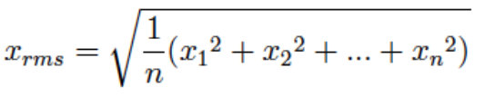

Each time the RMS of a chunk exceeds a certain threshold, we update a variable that keeps track of how long the signal was high. If the signal was high for 2-3 chunks then went low, a clap is registered. If the signal continues to stay high for more than 3 chunks, then we assume the audio is from a loud background noise. The threshold level is arbitrary, since it depends on the microphone’s sensitivity and background environment. In general, the level can be determined within a few test runs.

Occasionally a few false positives are returned by the program, especially due to sudden loud noises in the background. To overcome this, the user has to clap twice within one second to toggle the state of the lights.

**Threading**

To maximize the processing speed of the neural network, we use python’s built-in Thread library to carry out the clap detection and displaying the live video feed. Despite using multiple threads, the maximum processing speed of the neural network is two frames per second.

**Bluetooth Communication**

There are two main types of bluetooth: Bluetooth 2.0 (regular) and Bluetooth 4.0 LE. In Bluetooth 2.0, both devices have to be paired with each other to establish a continuous connection. In contrast, Bluetooth 4.0 LE (which stands for Low Energy) does not establish a continuous connection between two devices, but rather sends out pulses of information in short connections. As a result, the bluetooth device is usually idle when it is not receiving or sending data, which allows it to rest at a low energy state. For our project, we used Bluetooth 4.0 LE because the Raspberry Pi needs to send out bytes of information occasionally. Furthermore, since the Bluetooth LE module does not require a continuous connection with the Raspberry Pi, we can also send signals to the Bluetooth module from our phones (IOS and Android both supported) without disrupting the Pi to Ardunio communication.

We used the python third-party library bluepy to send communication via bluetooth. To connect to the Bluetooth module, we pass in the MAC address and service UUID of the module into bluepy pre-defined objects. After initialization, we sent text through bluetooth with the “write” method. We send the letters (encoded in bytes) “H” for HIGH, “L” for HIGH, and “D” for ‘human detected’ to the Arduino. Although these values are arbitrary, they are defined in our Ardunio script so that the microcontroller will know how to process the values. If any other information is sent through a phone, the message will be ignored.

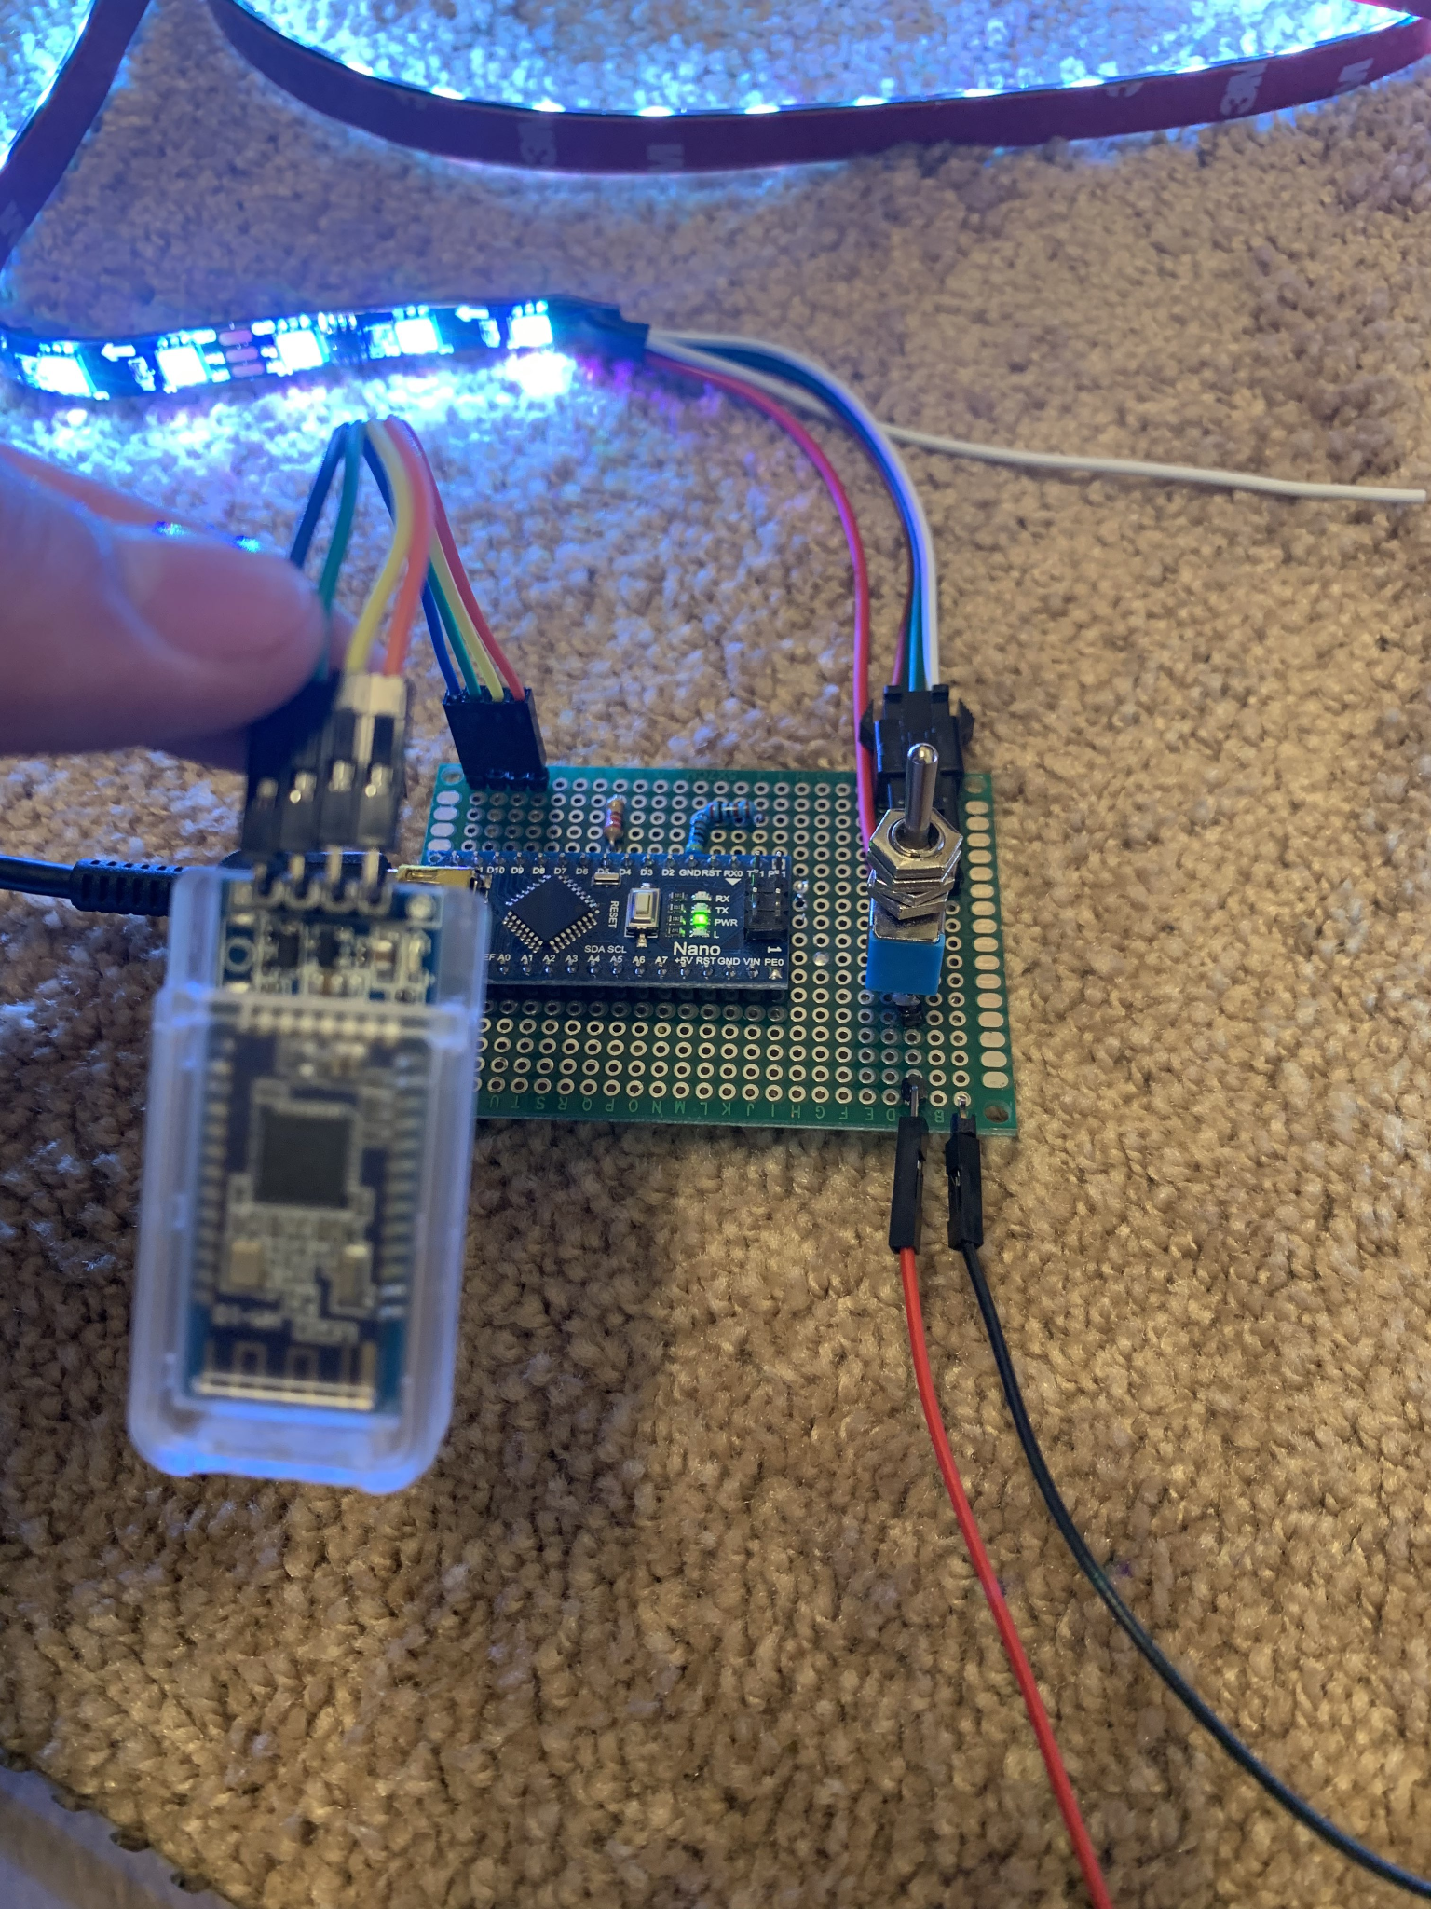

**Arduino**

For communication with the bluetooth module, the transmitter pin of the module is connected to the receiver of the nano, and the receiver pin of the module is connected to the transmitter of the microcontroller through a 3.3 voltage divider. The pins are connected directly to the TX and RX pins of the nano, so we can get information from the bluetooth module directly from serial communication. However, this prevents the nano from communicating with the computer via mini-b usb cable without unplugging the bluetooth module. As mentioned above, we use the byte values of “H”, “L”, and “D” to determine the state of the lights. If a double clap is detected, the lights will turn on or off indefinitely; “H” represents a HIGH value and “L” represents the LOW value. A “D” is sent to the nano if a person is detected within the camera frame, in which the nano will turn on the lights for a specified amount of time (default to 10 minutes). If the lights are already on due to a double clap (or via phone communication), then “D” has no impact and is ignored.

We purchased an Alitove LED strip which consists of 300 LEDs but has only 100 WS2811 microcontrollers. This implies that each microcontroller controls three LEDs. For its speed and extensive documentation, we used the FastLED V3.4 library to control our LED light strip. The library provides a FastLED array object in which the index of the array corresponds to the LED position in the light strip. This way, we can control the color, saturation, and hue of each triplet of LEDs.

**PCB Board**

Our circuit requires the Arduino Nano, power supply, light strip, and bluetooth module to all be connected to the same ground. The wiring can get very annoying and messy using a breadboard, so we soldered the Nano into a PCB and connected all the ground wires together.

PCB Schematic PCB Soldering

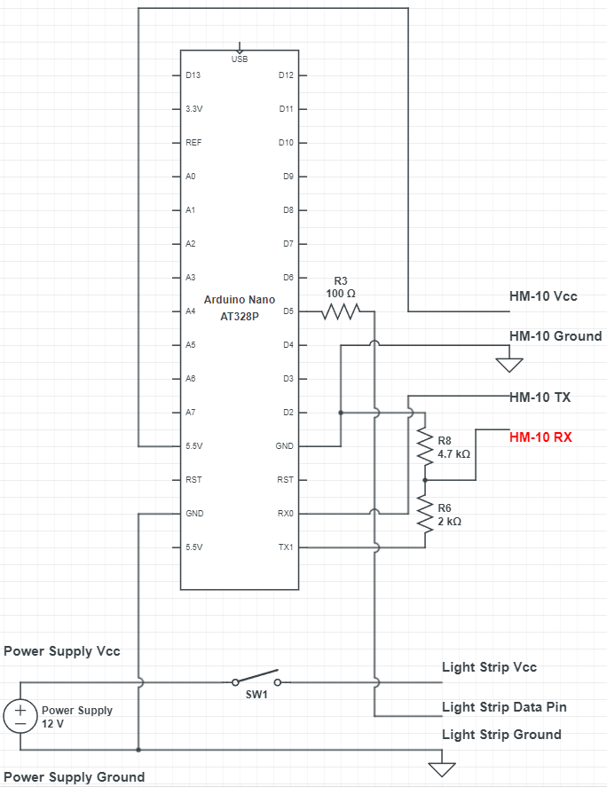 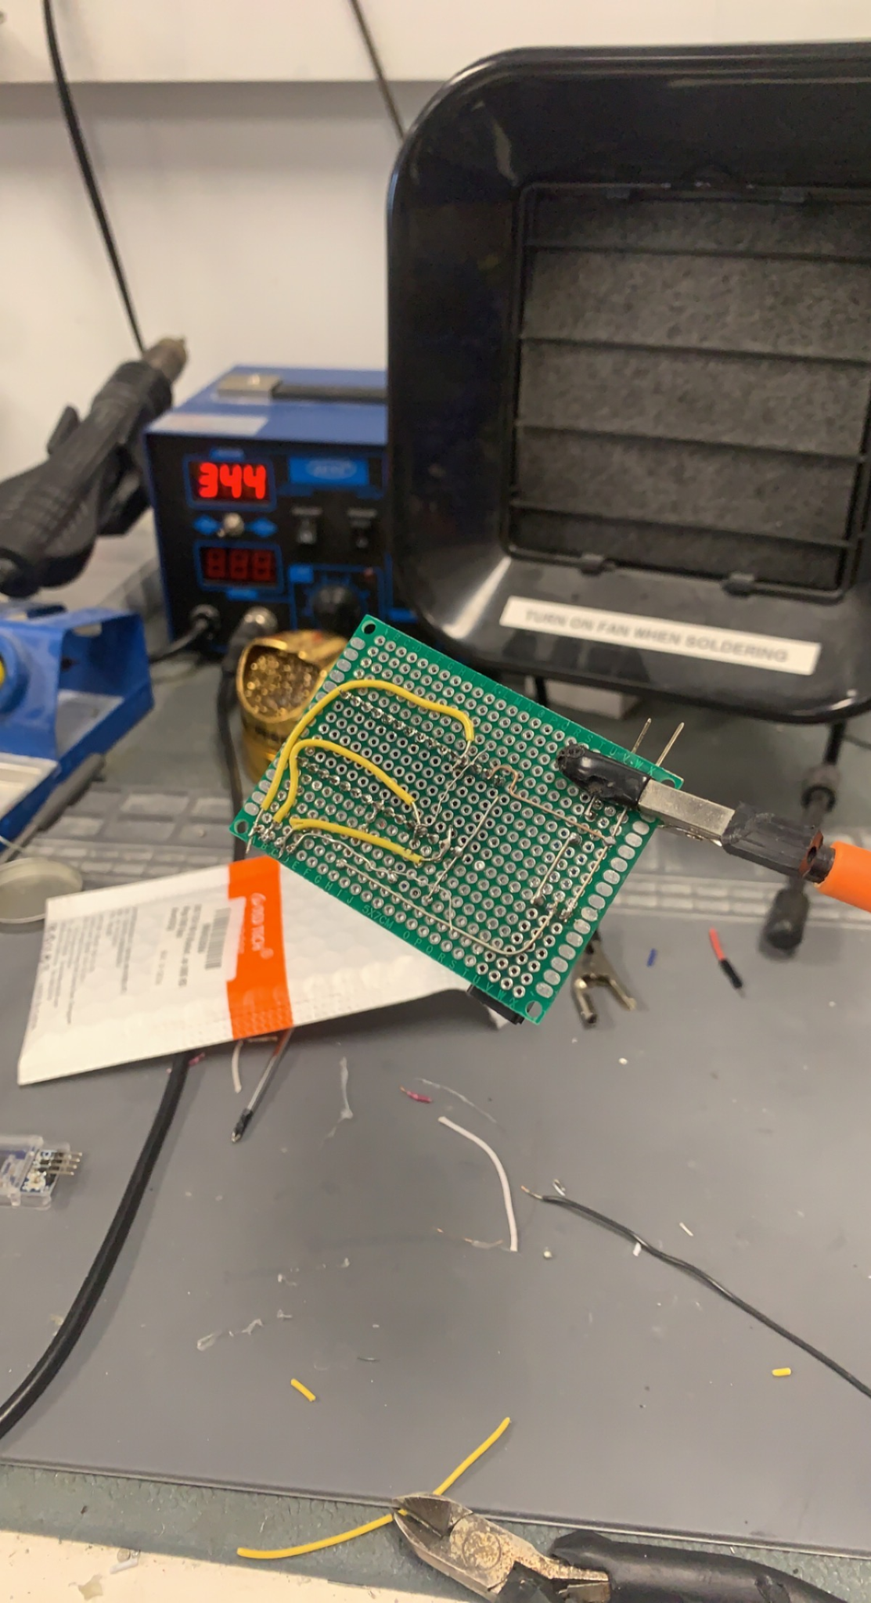

# **Step by Step Instructions**

1. Download Raspbian Pi OS and boot up the pi
2. Follow instructions from [How to Perform Object Detection with TensorFlow Lite on Raspberry Pi](https://www.digikey.com/en/maker/projects/how-to-perform-object-detection-with-tensorflow-lite-on-raspberry-pi/b929e1519c7c43d5b2c6f89984883588) to download the necessary Python packages and TF Lite Model.
3. Download the python Clap.py and python2bluetooth.py files from <https://github.com/Joshjppark/IEEE-Fall2021-QP> (or just download the main TFLite_detection_webcam.py file which includes interfaces for both functions).
4. Connect the camera and microphone to the Raspberry Pi

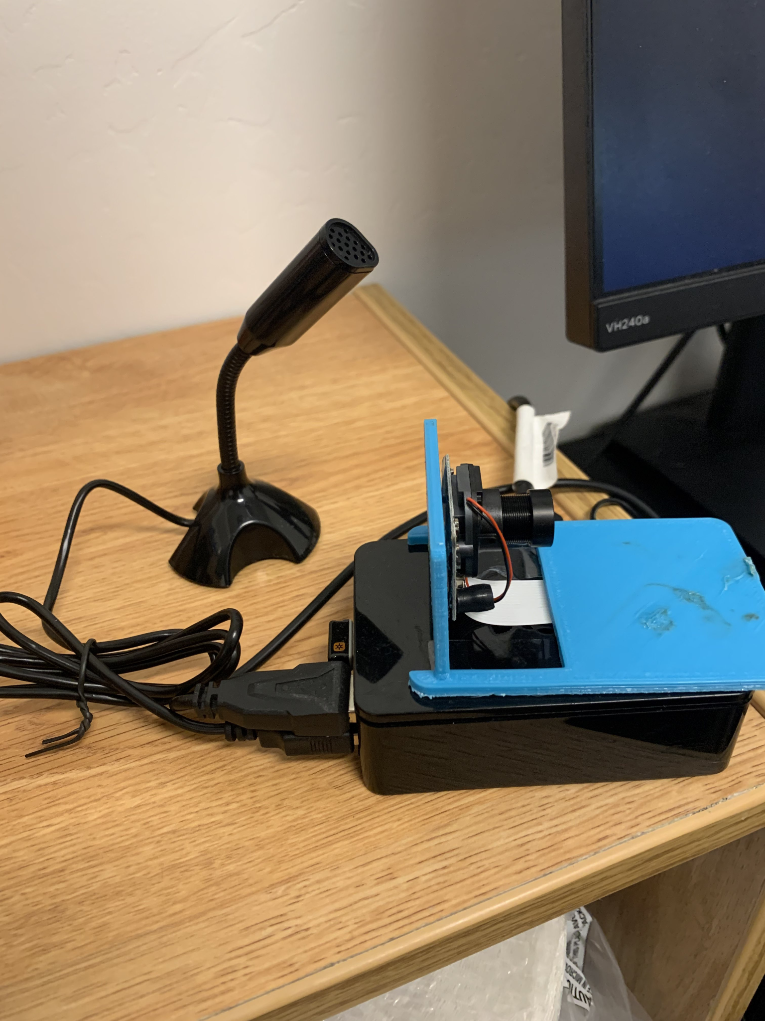

1. Connect the Ardunio Nano to the power supply and light strip

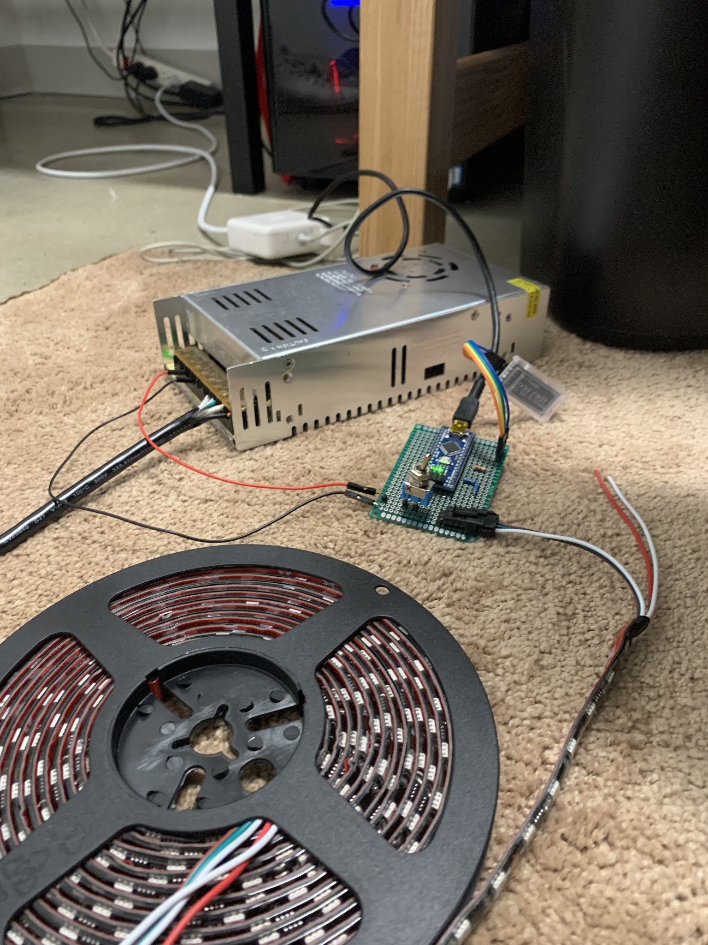

1. Enable bluetooth and download bluez; follow instructions from [How to Set Up Bluetooth on a Raspberry Pi](https://howchoo.com/pi/bluetooth-raspberry-pi)
2. Run command python TFLite_detection_webcam.py --modeldir=coco_ssd_mobilenet_v1

# **Team Member Roles and Contributions**

**Joshua Park** - Implemented the neural network and clap detection, enabled bluetooth communication, configured the Raspberry Pi, and soldered the circuit board. Wrote documentation.

**Anthony Tseng** - Programmed light patterns for the LED strip and the reception of the signal from the Raspberry Pi. Wrote documentation.

**Sammy Koujah** - Designed and created the 3-D printed model that keeps the camera mounted onto the raspberry pi.

# **Difficulties and Challenges**

**Neural Network**

The hardest part of implementing the neural network was actually downloading the required packages. I (Joshua Park) bought the Raspberry Pi 3 B+ back in 2017, and installed the most updated Raspbian operating system back then. When I tried to install the cv2 and Tensorflow packages onto my raspberry pi, there would always be some form of error. This was especially frustrating because the error would occur in the middle of the make or the sudo make install commands, which usually take hours to process. At first, cv2 required python versions 3.7 or higher, so I had to install that onto my Raspberry Pi. However, since my Pi was outdated, it was still defaulted to python 2.7. Python 3.7 was also hard to download, since the make or the sudo make install commands to download python itself would throw errors. Eventually, I just decided to completely reset my Raspberry Pi and install the new Raspberry Pi OS on my micro SD card since the new OS came with Python 3.7. After installing the new OS, everything worked smoothly and fine.

**Bluetooth**

Bluetooth 4.0 seemed superior to Bluetooth 2.0 from a project implementation standpoint, but actually coding it with Python proved to be much harder than expected. To use Bluetooth 4.0, we had to download it online. First, some websites said to download bluetooth through apt-get, whereas other websites said to download it through wget since the apt-get bluetooth was outdated. Naturally, we wanted the most updated version of bluetooth, so we downloaded bluetooth through wget. However, downloading through wget did not work since an error would be thrown in the make command. In the end, we just downloaded bluetooth with the apt-get command, which ironically downloaded nicely.

After downloading bluetooth, the systemctl activated bluetooth did not turn on bluetooth. Eventually, we came across a stackoverflow website: [Thank the Gods](https://stackoverflow.com/questions/35397290/cant-type-on-bluetoothctl/44079184) that said to run the command sudo modprobe btusb first, which allowed us to activate bluetooth. We also found a nice github repository: [Further Thank the Gods](https://github.com/KarimLakra/Python_communication_Bluetooth/blob/master/Transmitter.py) that helped us communicate with the HM-10 module.

# **Possible Improvements**

With a greater budget, we could purchase a Raspberry Pi Model 4 with 8 GB ram and a Google Coral usb that would allow our neural network to process up to 20 FPS rather than 2. We could also try to learn the inner workings of the neural network to optimize it for our environment. For example, we could train the neural network by pointing out false positives or missed human detection. Lastly, we could synchronize the LED strip with our music, which would really liven up the atmosphere of our depressing “STEM-student” dorms.

# **Conclusion**

Our final result differs greatly from our initial ideas and may be overly-complicated for the application, but we learned a lot about considering tradeoffs between cost, time, and performance.

Using a Raspberry Pi to offload the tasks requiring higher processing power and the Arduino to deal with the more menial tasks was also a good experience in multiprocessor systems, though the communication between the two could be improved.

# **Resources:**

Setup Raspberry Pi:

* [Raspberry Pi OS – Raspberry Pi](https://www.raspberrypi.com/software/)
* [How To Configure WiFi on Raspberry Pi: Step By Step Tutorial - Latest Open Tech From Seeed](https://www.seeedstudio.com/blog/2021/01/25/three-methods-to-configure-raspberry-pi-wifi/)

Object Detection:

* [How to Perform Object Detection with TensorFlow Lite on Raspberry Pi](https://www.digikey.com/en/maker/projects/how-to-perform-object-detection-with-tensorflow-lite-on-raspberry-pi/b929e1519c7c43d5b2c6f89984883588)
* [YOLO and Tiny-YOLO object detection on the Raspberry Pi and Movidius NCS](https://www.pyimagesearch.com/2020/01/27/yolo-and-tiny-yolo-object-detection-on-the-raspberry-pi-and-movidius-ncs/)
* [[solved] Connecting Pi bluetooth to Arduino and HC-05](https://forums.raspberrypi.com/viewtopic.php?t=247293)
* [Overview · FastLED/FastLED Wiki · GitHub](https://github.com/FastLED/FastLED/wiki/Overview)

Clap:

* [Detect tap with pyaudio from live mic](https://stackoverflow.com/questions/4160175/detect-tap-with-pyaudio-from-live-mic)
* [Playing and Recording Sound in Python – Real Python](https://realpython.com/playing-and-recording-sound-python/)
* [RMS Amplitude](https://www.hackaudio.com/digital-signal-processing/amplitude/rms-amplitude/#:~:text=An%20analysis%20used%20for%20the,positive%20and%20negative%20amplitude%20values)
* [iZotope Tips and Tutorials Digital Audio Basics: Audio Sample Rate and Bit Depth](https://www.izotope.com/en/learn/digital-audio-basics-sample-rate-and-bit-depth.html)
* [Let's Build an Audio Spectrum Analyzer in Python! (pt. 1) the waveform viewer.](https://www.youtube.com/watch?v=AShHJdSIxkY&list=PLX-LrBk6h3wQVsrldsQdtKmeTygurKiuS&ab_channel=MarkJay)

Bluetooth:

* [How to Set Up Bluetooth on a Raspberry Pi](https://howchoo.com/pi/bluetooth-raspberry-pi)
* [Using BLE Devices with a Raspberry Pi](https://www.argenox.com/library/bluetooth-low-energy/using-raspberry-pi-ble/#installing-bluez-bluetooth-stack-on-the-raspberry-pi)
* [HM-10 Services and Characteristics](https://acoptex.com/uploads/HM10ServicesandCharacteristics.pdf)
* [Control Bluetooth LE Devices From a Raspberry Pi](https://www.instructables.com/Control-Bluetooth-LE-Devices-From-A-Raspberry-Pi/)
* [Python_communication_Bluetooth/Transmitter.py at master · KarimLakra/Python_communication_Bluetooth · GitHub](https://github.com/KarimLakra/Python_communication_Bluetooth/blob/master/Transmitter.py)
* [Can't type on bluetoothctl](https://stackoverflow.com/questions/35397290/cant-type-on-bluetoothctl/44079184)